|  |
| --- |
| Invent |
| iResearch |
| Version 2.1 Release notes |

|  |
| --- |
| Last update  11/5/2010 |

Table of Contents

Installation 3

Installation Prerequisites 3

Installation Steps 3

Macro Security 3

Features 4

Changes in Version 2.0 – Beta #1 (27-Sep-2010) 4

Changes in Version 2.0 – Beta #2 (7-Oct-2010) 6

Changes in Version 2.0 – Final Preview (10-Oct-2010) 7

Changes in Version 2.0 – Final Version (16-Oct-2010) 7

Changes in Version 2.1 (4-Nov-2010) 8

# Installation

The installer file is an MSI file that needs a privileged user (usually an IT Administrator) to install it, there is no special instructions needed as it is a very simple installer.

## Installation Prerequisites

* Microsoft Office 2007 (Installed using the Complete Installation option)
* Microsoft Office 2007 Service Pack 2:  
  <http://www.microsoft.com/downloads/details.aspx?FamilyId=B444BF18-79EA-46C6-8A81-9DB49B4AB6E5&displaylang=en>

## Installation Steps

1. Please uninstall any previous version of iResearch before attempting to install the new one
2. Close Microsoft Office Word 2007
3. Close Microsoft Office Excel 2007
4. log off and login using an Admin account
5. Install iResearch using the MSI file
6. Restart the machine

## Macro Security

After installing iResearch, when opening MS Word, you may be prompted with the following notice:

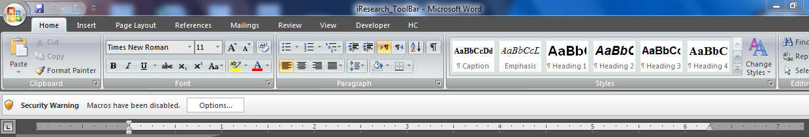This security warning due to the macros in iResearch, simply click the options button and select ‘Enable this content for the *’iResearch_Toolbar.dotm’*

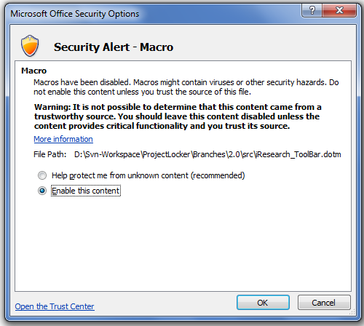

# Features

## Changes in Version 2.0 – Beta #1 (27-Sep-2010)

1.       The reports provided are :

* Flashnote
* Company Note
* Initiation of coverage
* Sector note
* Macro and strategy report.

The contents of each (font, tables, charts) will be the same, the only thing different is the front pages of each report.

All the elements will show up on the front page when a report is created including text in the right column, table at the bottom of the front page, section title, bullets, text, etc.

4.       Page numbers will begin on the second page.

5.       iResearch colors have remained the same, no changes.

6.       The banner on the top should be one solid color, matching the color of the HC logo. The text in the top banner has been changed and shifted around, the headline font is Calibri 36 and the smaller text is Calibri 10.

7.       The headers and footers on the rest of the pages have been changed as well.

8.       The regular text for the template will be Calibri 11pt. All text will be left justified, except for that in the right column on the front page which will mostly be right justified.

9.       The Section Title text will be Calibri 20.

The subsection title is Calibri 14 Bold

Within Subsection Title is Calibri 11 Bold."

10.   The regular text on the right column on the front page is Calibri 10.5 with the Target Price and Price Performance in Bold.

The text for the note is Calibri 8.

The date is Calibri 12 and it is in Bold.

The contact details are Calibri 11 and the name will be in bold.

Spacing between these elements of text will be Calibri 9.

Any text in between lines (in a cell) will have 2pt spacing (you will see this in the page layout tab) above and below.

You will see the same before the Note in that column.

11.   The first sentence of each paragraph on the front page will be bolded, except for the flashnote, which has special headlines at the beginning of each paragraph.

12.   Facility to insert sections that show up with a section title and bullet points. The bullet points will be aligned as shown in text and will be the blue shown in text.

13.   Facility to insert a subsection and within subsection title.

18.   The source should always show up like this Source: HC. It is 8pt font. The source should show up with the whole table and it has 2pt line spacing before.

19.   The note will be the same size and font of the source, analysts should be able to add this along with a superscript note in the headline of the table.

20.   In charts, there will be no gridlines and no legend for now

21.   The headlines of charts will be like the tables, with a line above and below, same text size, line point spacing, bolding. They will also have a line below a source under just like in tables.

22.   Facility to add a single chart, stretched all the way to the other side of the page with solid lines above and below, or two charts with a separator in the lines which have been done by adding a column between them that has no borders.

23. Use same margins for all pages including the front page

24. Having Text Sections inside a custom layout table

25. Start page numbering on second page from 2 not 1

26. Use the updated logo

27. Disclaimer font is 11 not 8

## Changes in Version 2.0 – Beta #2 (7-Oct-2010)

In this beta version; the facility to insert Table with the new look and feel was added in addition to the facility to insert Subsection and bullets, also the followings issues raised from Beta #1 were fixed:

* The line under the HC logo on the second page should not be there. It should stop right before the logo
* In the pie chart: Source box should be 0.01 in height. The whole thing should be in a table like with the bar chart exactly.
* Line chart: Source box should be 0.01 in height. The whole thing should be in a table like with the bar chart exactly. The font should be Calibri 9 with a line on the y axis side like bar chart.
* Dual pie chart: The width of the two columns should be 3.5 and the center column should be 0.2.
* Dual bar chart: Same as dual pie chart.
* The text box; the thin column in the center a tiny bit smaller so the column on the left can fit more text
* Remove: contact sheet, contact card, price table, dual line and pie chart.
* Remove: placeholders.
* The Macro and Strategy piece should say Macro and Strategy Note in the top left cell in the header of the front page.

## Changes in Version 2.0 – Final Preview (10-Oct-2010)

The final preview version is created to fix the following issues:

* The title of the Key Indicator table on the first page is aligned to the right and seems to be cut off, however it needs to be aligned to the left.
* When inserting a table, it does seem to show up with dotted lines going across; however it should have no lines going across.
* When inserting a Dual bar chart; the column in between the bar charts should look like the column in between the pie charts
* When inserting a table, it has no title

## Changes in Version 2.0 – Final Version (16-Oct-2010)

The final version was released to HC with the following amends:

* New logo: Alembic and HC logos side by side in the header
* All font notes has been changed to AlembicHC

## Changes in Version 2.1 (4-Nov-2010)

Based on the feedback from the analysts after using the version 2.0 for a while (around 3 weeks), the following changes has been requested and applied in version 2.1:

* All text in charts is now Calibri 7
* Chart size changed in all charts
* Charts must not touch lines of tables they are in
* When inserting a Section, the “this is a side note” text was removed.